Specification / Scope:
The system to be designed will be a relational database management system that is capable of storing information required for multiple formula 1 championships. It will contain the following entities:

- Driver
- Team
- Race Record
- Race
- Competition (ie,championship)
- Circuit

The system must be able to allow access to the following information:

- Driver
  - Name.
  - DOB.
  - Team.
  - Race times.
  - Competitions entered.

- Team
  - Team name.
  - Location.
  - Team Members.

- Race
  - Date of race.
  - Time of race.
  - Race Circuit.
  - Competition the race is a part of.

- Circuit
  - Circuit name.
  - Location.

- Competition
  - Competition name.
  - Circuits in competition.
  - Race results for competition.

The system must be able to perform the following functions:

- Add / Remove a driver.
- Add / Remove a Team.
- Add / Remove a circuit.
- Add / Remove a competition.
- Record the results of a race.
- Display competition results / Calculate winner.
- Display any information stored in the database as stated above.
Assumptions:

I have assumed the following:

- A driver may only belong to one team.
- A team may have multiple drivers.
- A driver may not enter more than one race on a given day.
- A competition may not have more than one race on a given day.
- A competition may have any number of races.
- No two circuits have the same name.
- No two teams have the same name.

Table Normalisation:

From the initial description I deduced the following structure with the following functional dependencies:
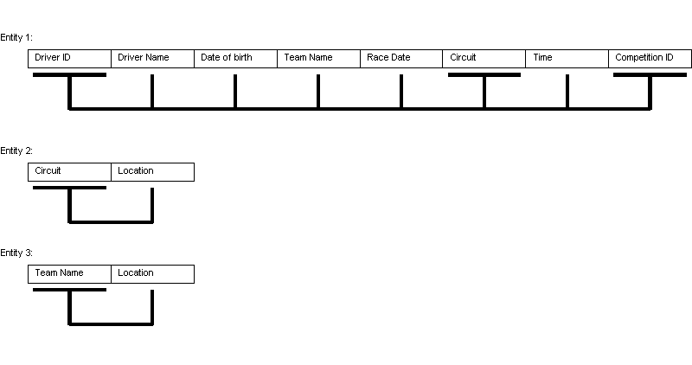
Entity 1. From the driver ID, the circuit and the competition ID you can determine all other attributes.
Entities 2 and 3 are already in BCNF so require no more work. These entities will be the “Circuit” and “Team” entities. Entity 1 is in need of normalisation:

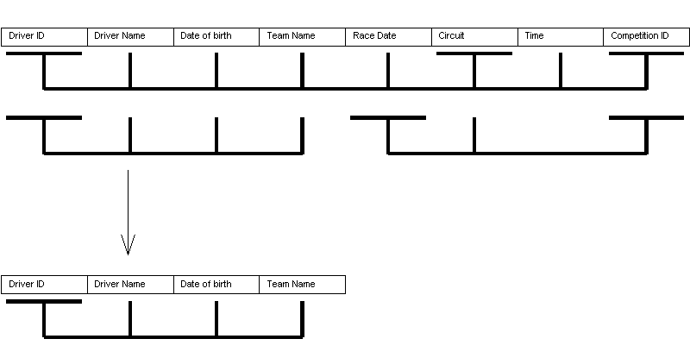
From this initial normalisation we now have another entity in BCNF. This will be the “Driver” entity.

The remaining table still needs further normalisation:
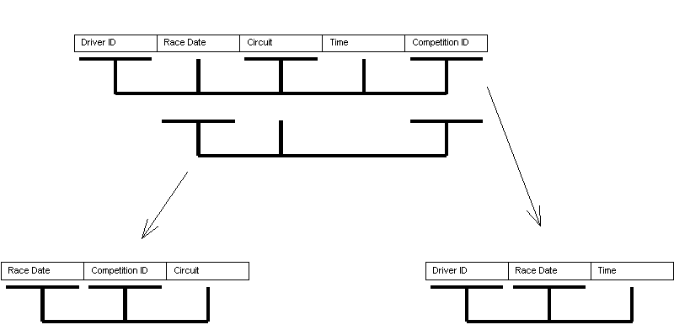
By normalising to this point we now have two entities that are in BCNF. These entities are the “Race” and “Race Record” entity. So the result is 6 BCNF entities:

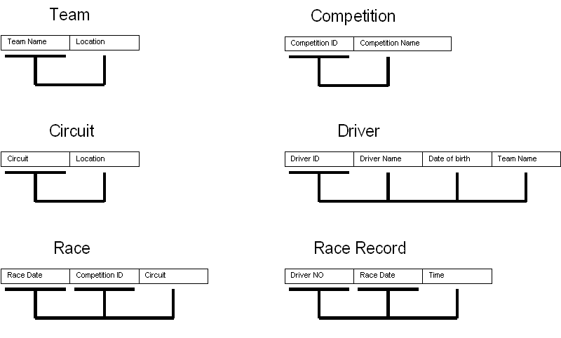
With the above structure we are able to avoid all update, insert and delete anomalies. The only issue I can see with this is that you may want to add a competition without assigning a race to it. That is why I have decided to add an additional entity called “Competition” and have it referenced to in “Race”. With this in mind the final entities and their attributes are as follows:
Final Entities:
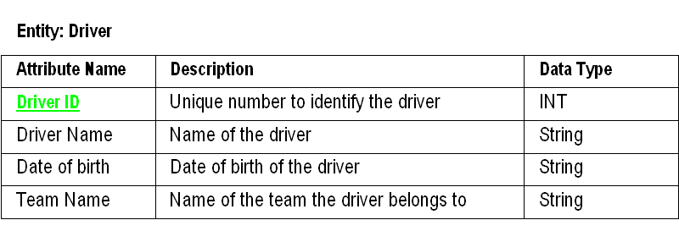

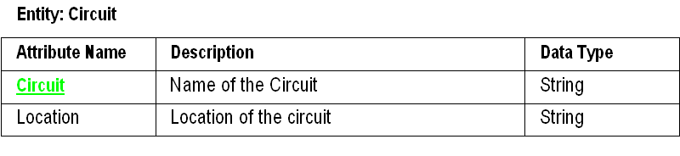

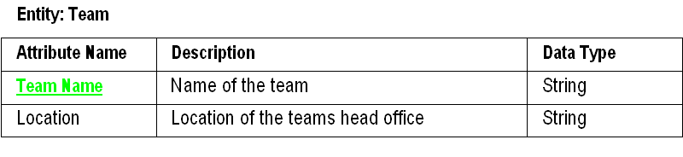
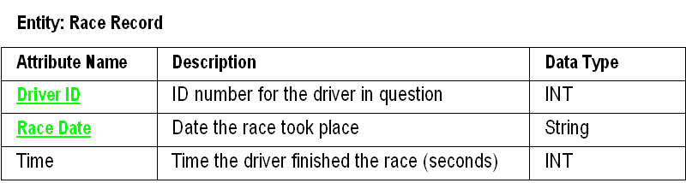

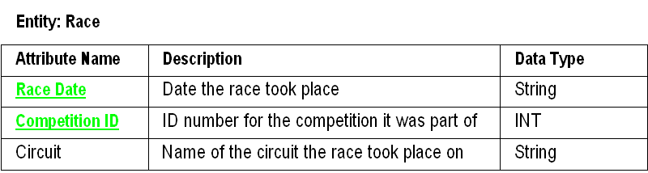

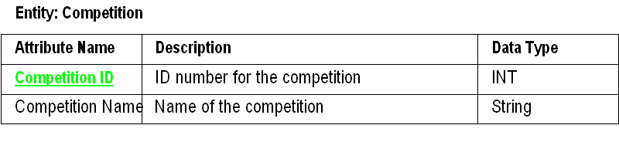

RI Diagram:

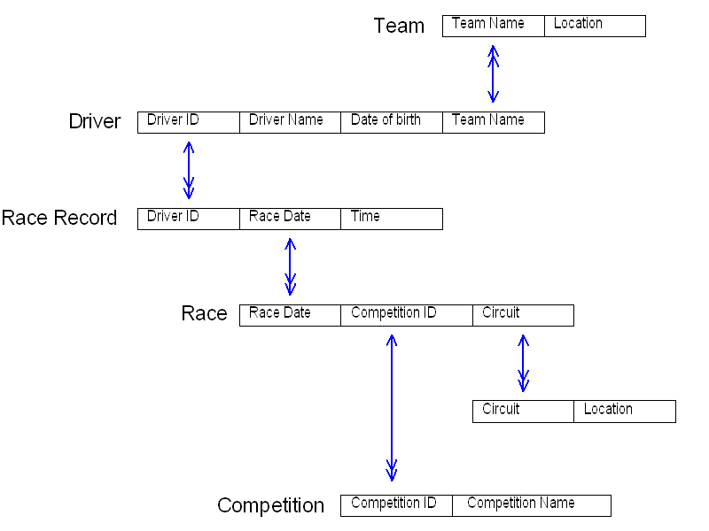
EAR Diagram:
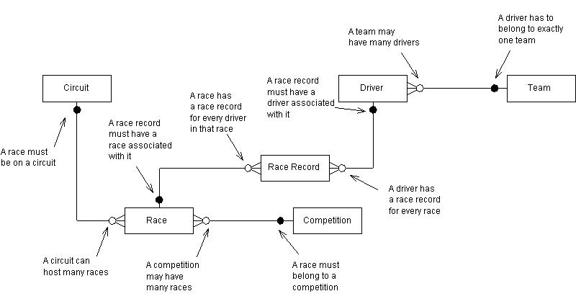
NOTE: Attributes have been omitted for clarity, please see the following page.
Details of entity attributes :

Driver(Driver ID,Driver Name, Date of birth,Team Name)
Race Record(Driver ID, Race Date, Time)
Race(Race Date, Competition ID,Circuit)
Circuit(Circuit Name, Location)
Competition(Competition ID,Competition name)
Team(Team Name, Location)

